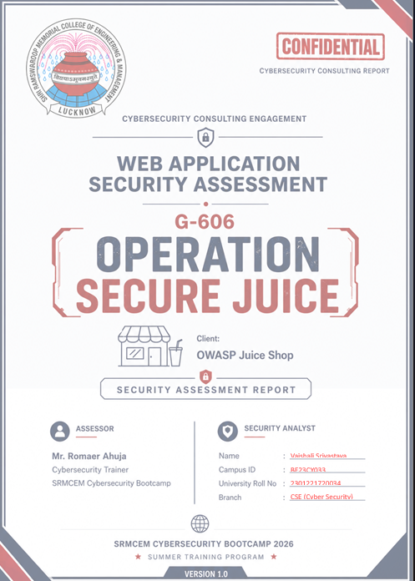

Executive Summary
- Purpose of Assessment :
- The objective of this security assessment was to evaluate the security posture of the OWASP Juice Shop web application by identifying vulnerabilities, security misconfigurations, and weaknesses that could be exploited by attackers.
- OWASP Juice Shop is probably the most modern and sophisticated insecure web application ! It can be used in security trainings, awareness demos, CTFs and as a guinea for security tools!
- OWASP Juice Shop encompasses vulnerabilities from the entire OWASP Top Ten along with many other security flaws found in real-world applications!
- The application contains a vast number of hacking challenges of varying difficulty where the user is supposed to exploit the underlying vulnerabilities. The hacking progress is tracked on a score board. Finding this score board is actually one of the (easy) challenges!
- Pentesting proxies and security scanners can use Juice Shop as a target application to evaluate how well their tools handle JavaScript-heavy frontends and Rest APIs.

- Scope of Assessment :
The scope of this security assessment covered the OWASP Juice Shop application, which is an intentionally insecure web application used for educational purposes. The following components were included in the assessment:
- Application Endpoint
- Finding the score board (Containing Hacking Challenges).
- Gaining Information related to OWASP Juice Shop (Finding key vulnerabilities and technology stack).
- Finding Attack Surface .
- Exploiting Vulnerabilities (Using Damn Vulnerable Web Application)
- Access control measures.
- OWASP Risk Mapping
- Risk Register
- Recommendation and Conclusion of the project .
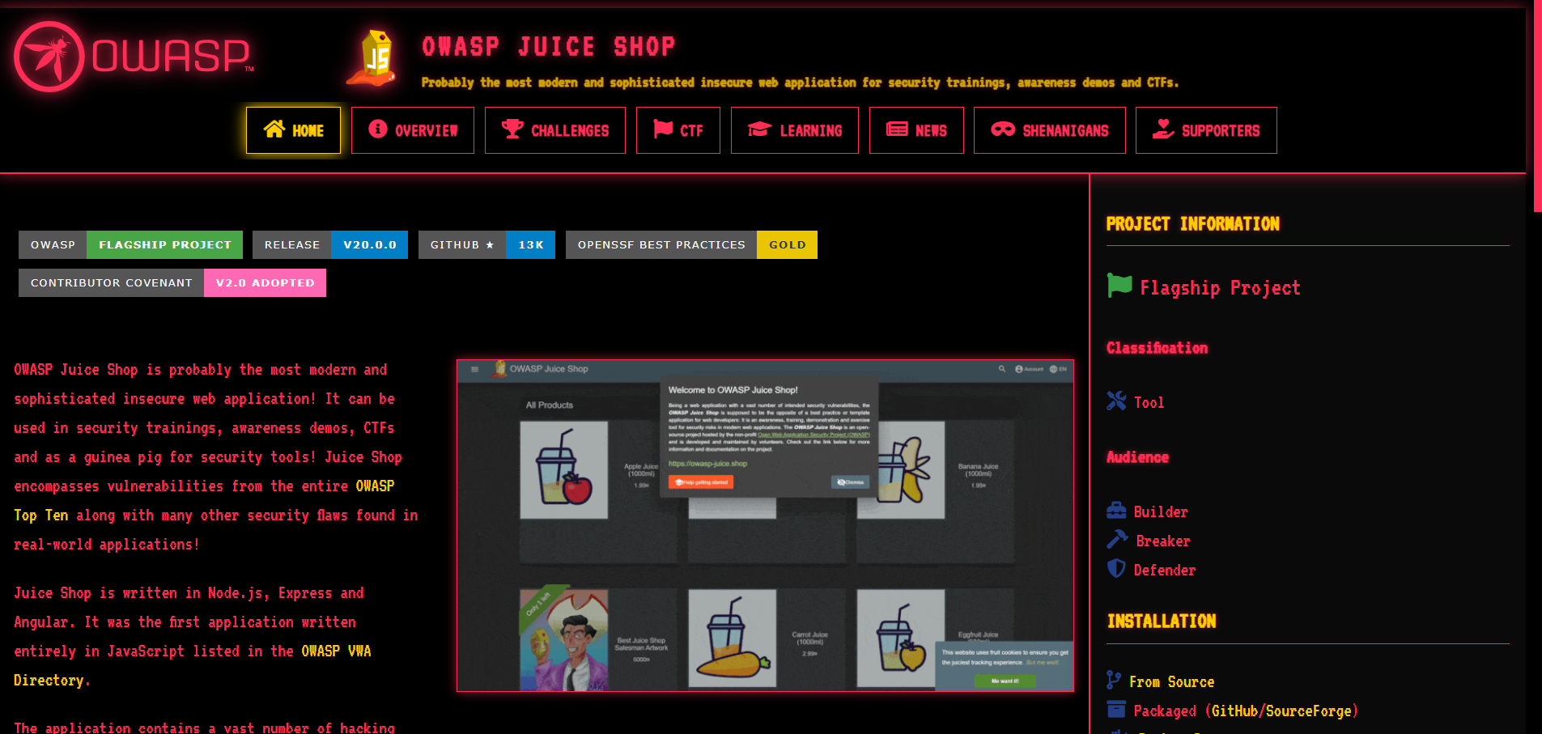

Client Overview
- Application Description :
- Purpose : The target application, OWASP Juice Shop, is an open-source intentionally insecure web application. It simulates a modern e-commerce platform and is widely used for security awareness training, developer education, and penetration testing practice.

- User base :
- Security Learners & Students — individuals learning ethical hacking, VAPT, or preparing for certifications like CEH, OSCP, or eWPT use Juice Shop as a hands-on lab.
- Developers — software developers use it to understand how common vulnerabilities like XSS, SQLi, and broken auth appear in real-world code, so they can avoid them in production.
- Security Trainers & Organizations — companies and universities deploy it internally for security awareness workshops, red team exercises, and training programs.

- VISIT : https://demo.owasp-juice.shop
- The OWASP Juice Shop is an open-source project hosted by the non-profit Open Worldwide Application Security Project (OWASP) and is developed and maintained by volunteers. Check out the link below for more information and documentation on the project.
- It is an awareness, training, demonstration and exercise tool for security risks in modern web applications.
- Home page , About us , Photo Walls , Score Board , Login , etc .

- Google Dorking :
- Site : OWASP-Juice.Shop -> https://juice-shop.github.io/ (Useful for attacker)
- Site : OWASP-Juice.Shop filetype:pdf -> https://god.owasp.de/archive/2018/slides/2018-god-kimminich.pdf (One Interesting Page)
- Site : OWASP-Juice.Shop security -> https://pwning.owasp-juice.shop/companion-guide/latest/part1/categories.html (Security- related page)

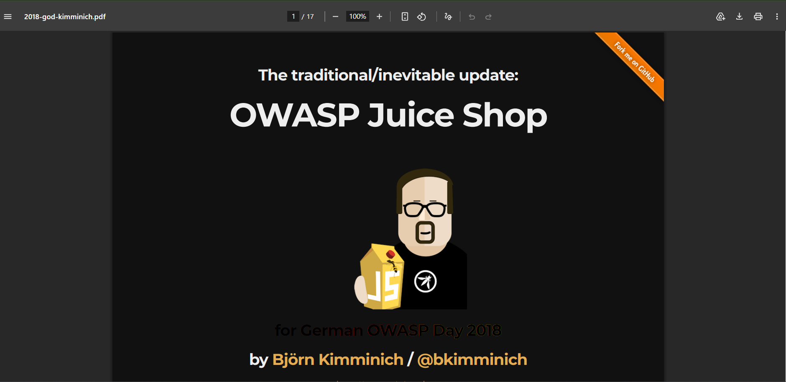

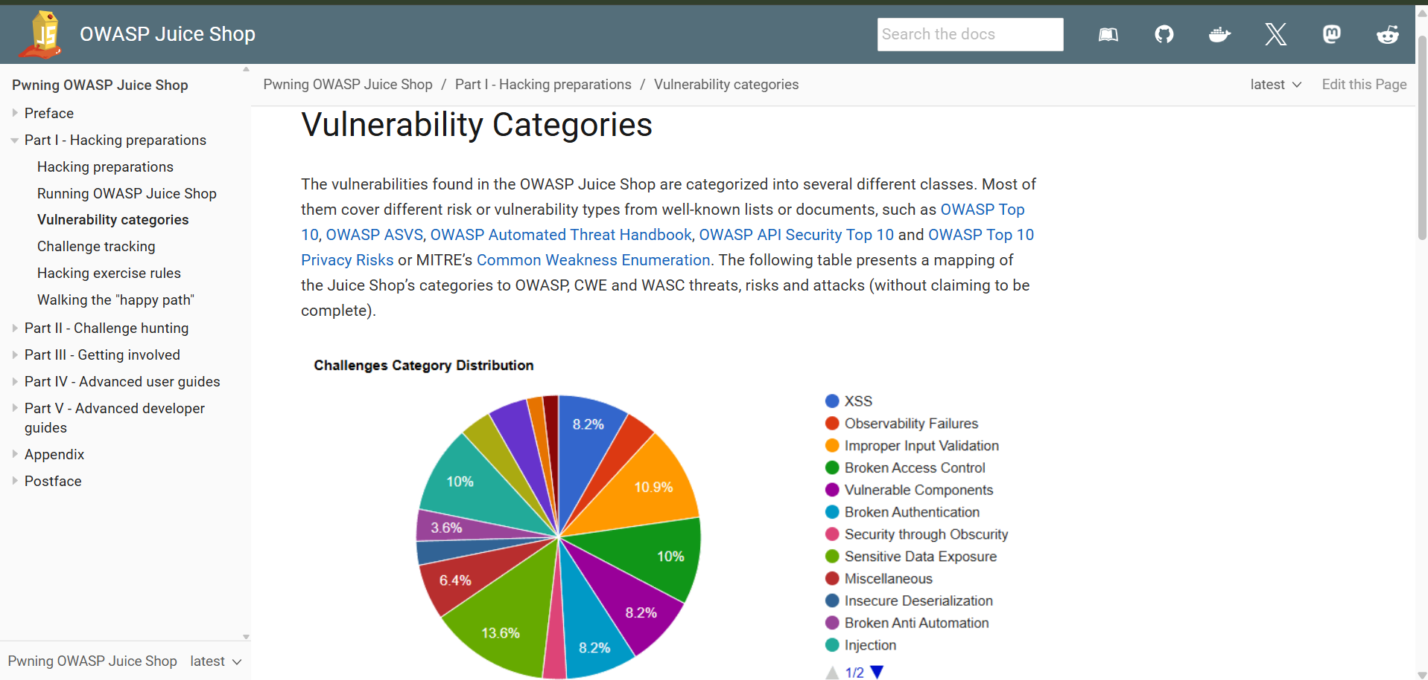

- Tech Stack : By using Wappalyzer we have known the Tech-Stack of OWASP Juice Shop .
- JavaScript Framework : Zone.js , Angular
- Font Script : Google Font API , Font Awesome
- Programming Language : TypeScript , Node.js

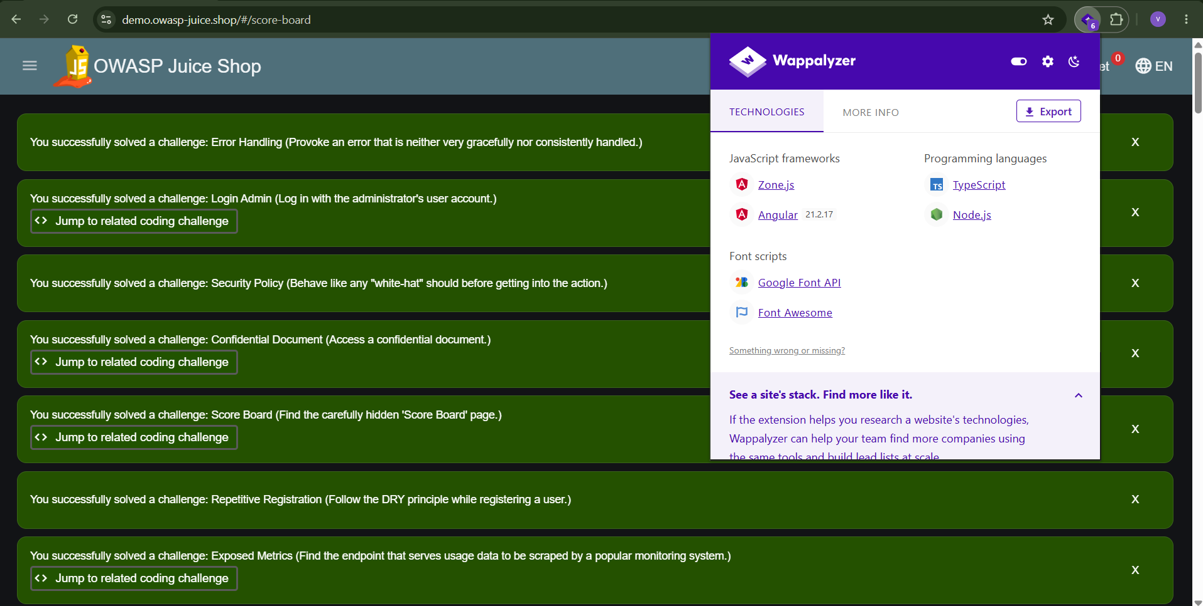

- Technology Profile : By using builtwith.com we get to know about the basic knowledge of technologies used in this website.
- Web Server : Apache 2.4
- Name of Server : Strato DNS
- Verified Link : NMP Publisher , NMP CLI

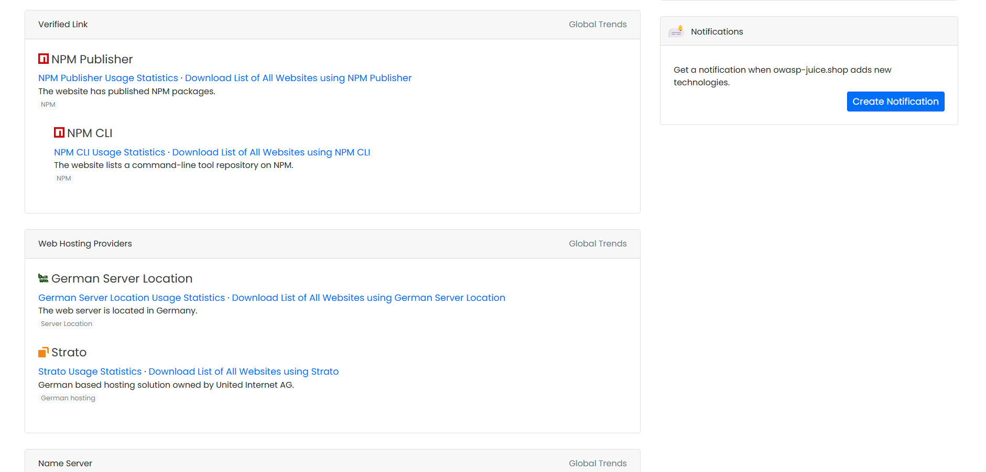

- Firewall :
- Firewall used OWASP Juice Shop by wafw00f : Fastly (Fastly one)

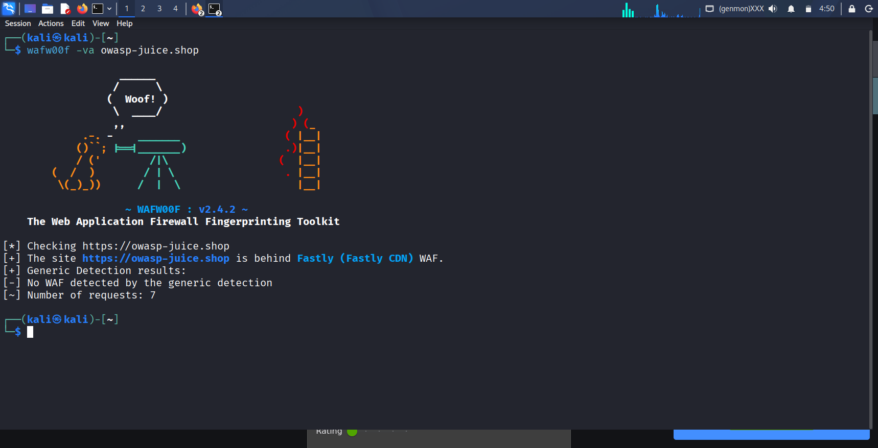

Reconnaissance Findings
Reconnaissance is the first phase of penetration testing where the assessor collects information about the target application without exploiting it. The goal is to map the attack surface and identify potential entry points
Information gathered without directly interacting with the application.
- Technology Fingerprinting and Server Information Disclosure via Whatweb :
- IP Server : 81.169.145.156
- HTTP Server : Heroku
- Web Hosting Country : Germany
- Markup Language : HTML5

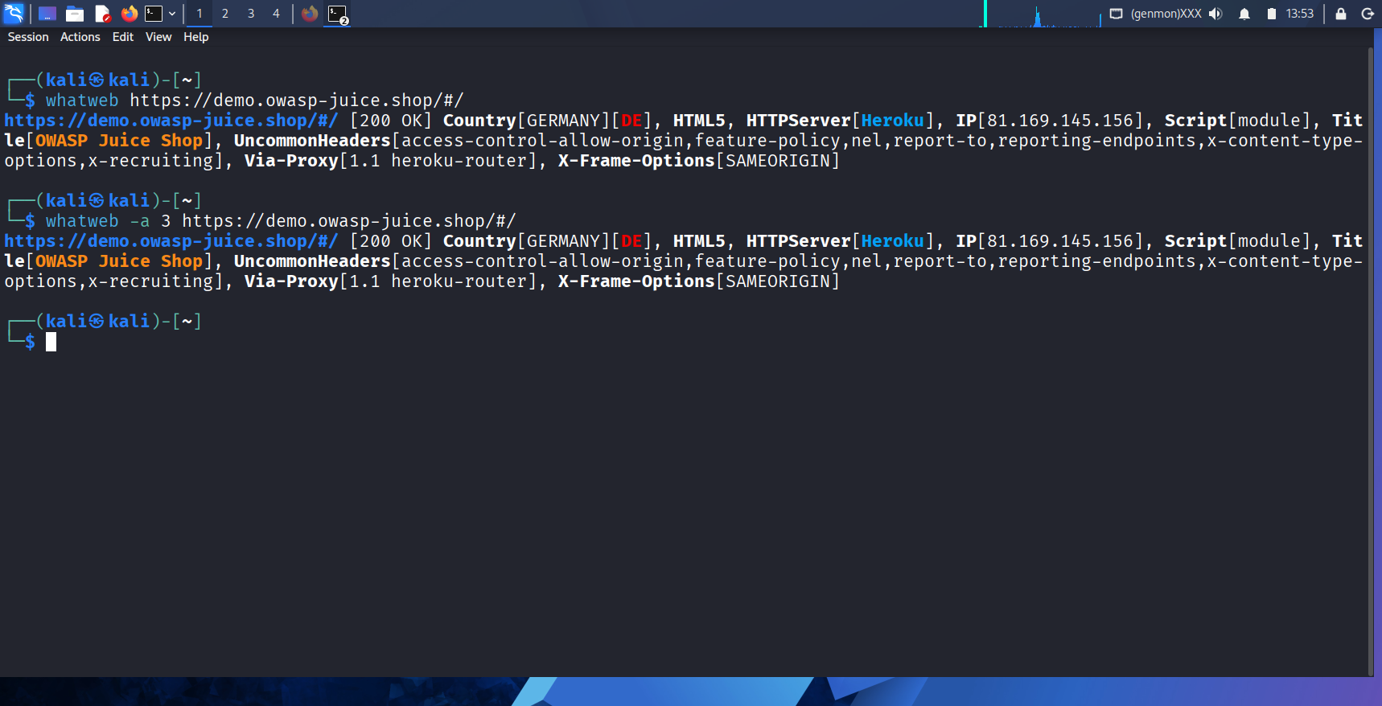

- ICAAN lookup :
- Name: owasp-juice.shop
- Registry Domain ID: DO2909101-GMO
- Domain Status:
- active
- Nameservers:
- docks10.rzone.de
- shades01.rzone.de
- Dates
- Registry Expiration: 2026-11-20 23:59:59 UTC
- Registrar Expiration: 2026-11-20 23:59:59 UTC
- Updated: 2026-02-19 09:34:54 UTC
- Created: 2017-11-20 10:26:02 UTC

- Nslookup :
- IPV4(A records) : 81.169.145.156
- IPV6(AAAA records) : 2a01:238:20a:202:1156::0
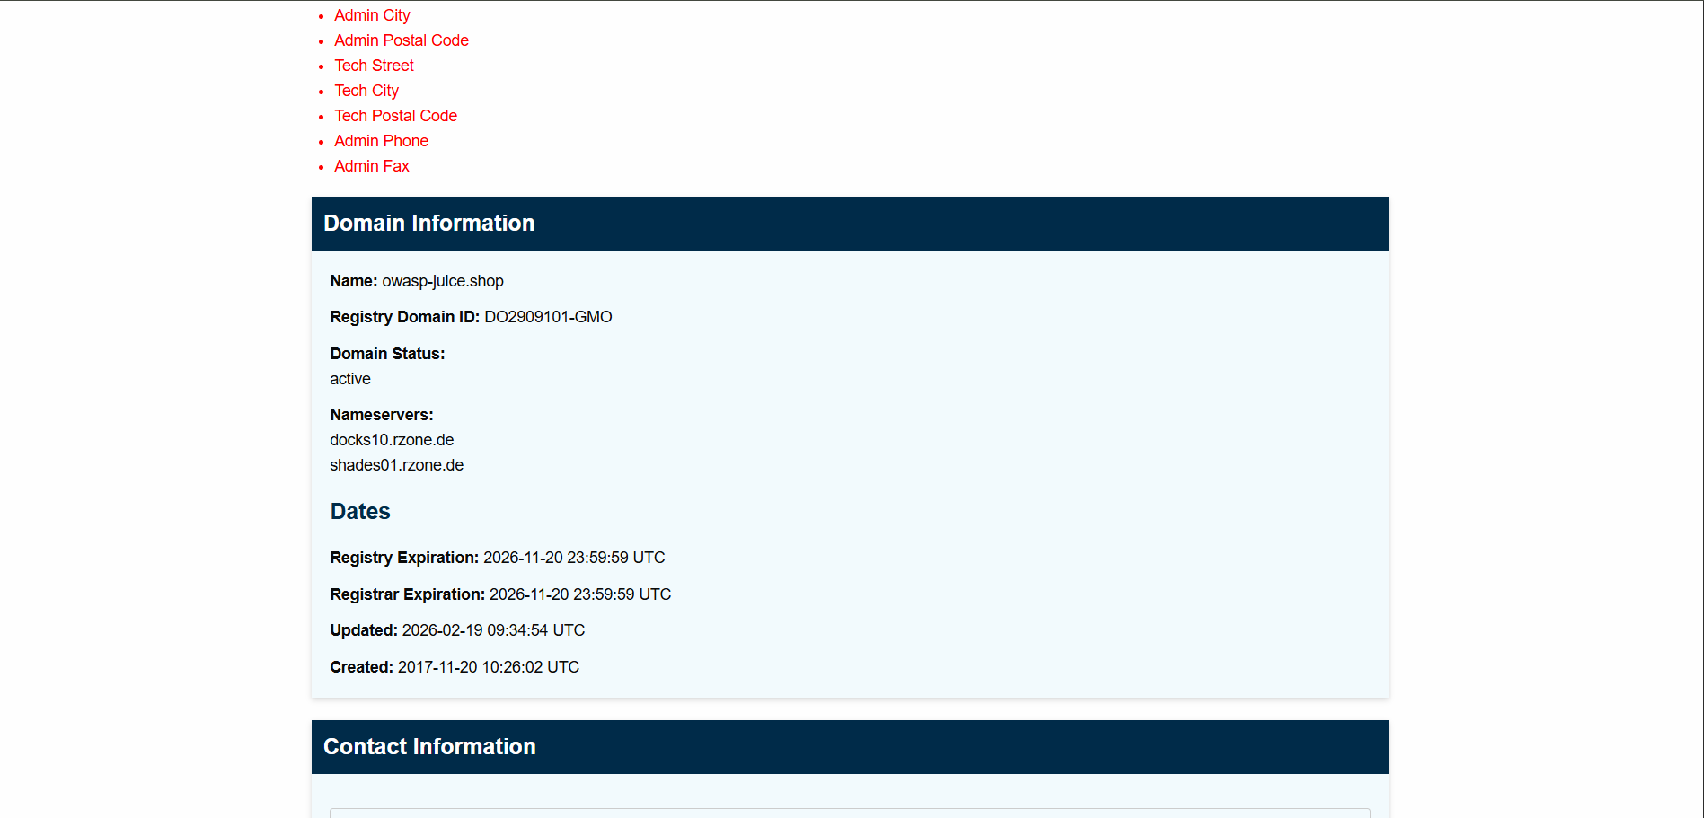

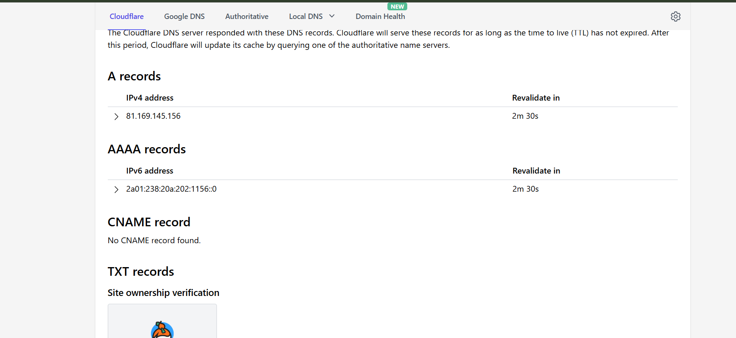

- Port Scanning :
- Port scanning is a reconnaissance technique used to identify open ports and services running on a target system. Each port corresponds to a specific service or application, and by scanning them, an assessor can determine what is accessible and potentially exploitable on the target.
- Nikto Command : Using Nikto command in kali linux we can find the Vulnerabilities of Web Server.
- Server banner changed from ‘Heroku’ to ‘Apache/2.4.68(Unix)’
- The Content-Encoding header is set to ‘deflate’ which may mean that the server is vulnerable to the BREACH attack.
- Scan Terminated with 19 errors and 12 items reported on remote host.
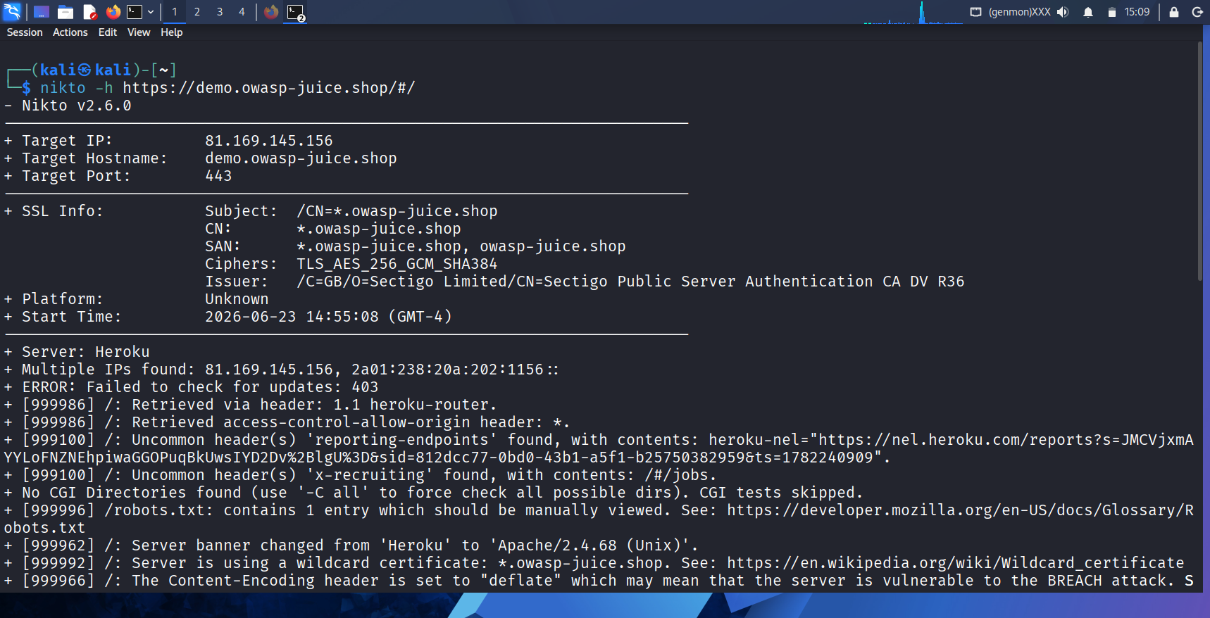
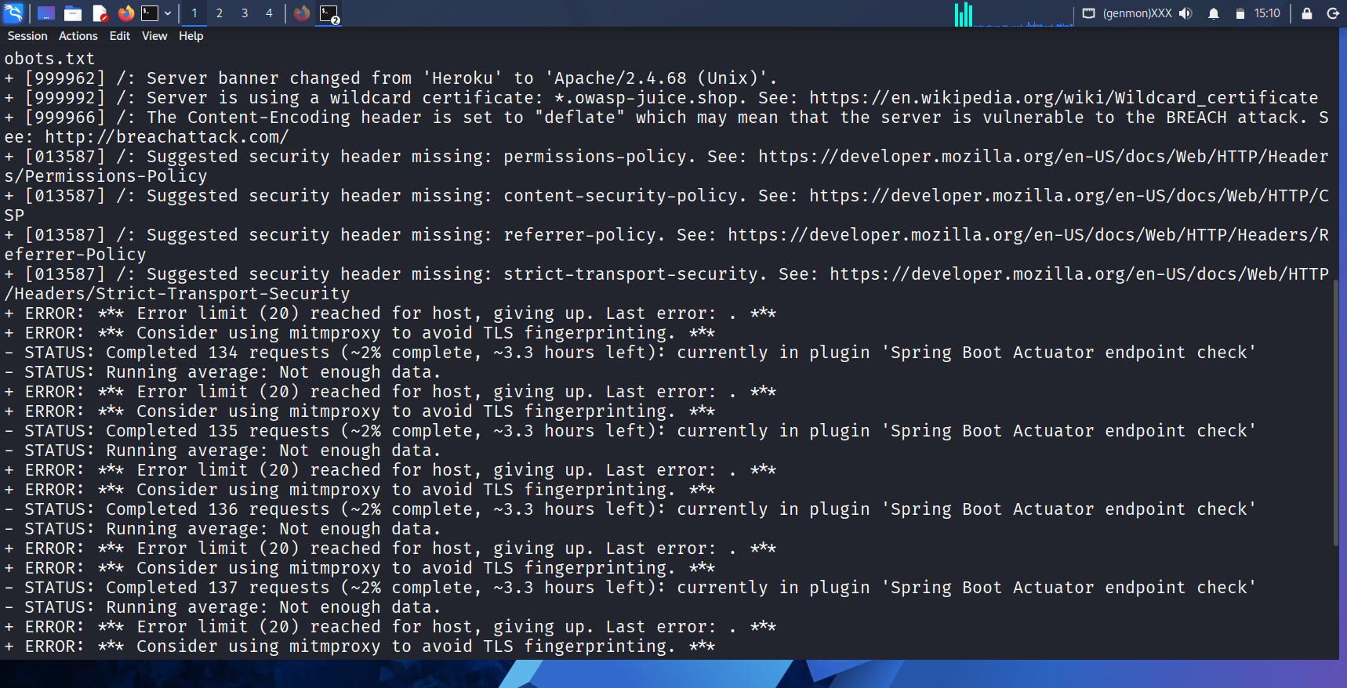
- Certificate information :
- Certificate Issue By :
- Common Name(CN) → Sectigo Public Server Authentication CA DV R36
- Organization (O) → Sectigo Limited
- Issued on → Thursday, September 25, 2025 at 5:30:00 AM
- Expires on → Saturday, October 17, 2026 at 5:29:59 AM
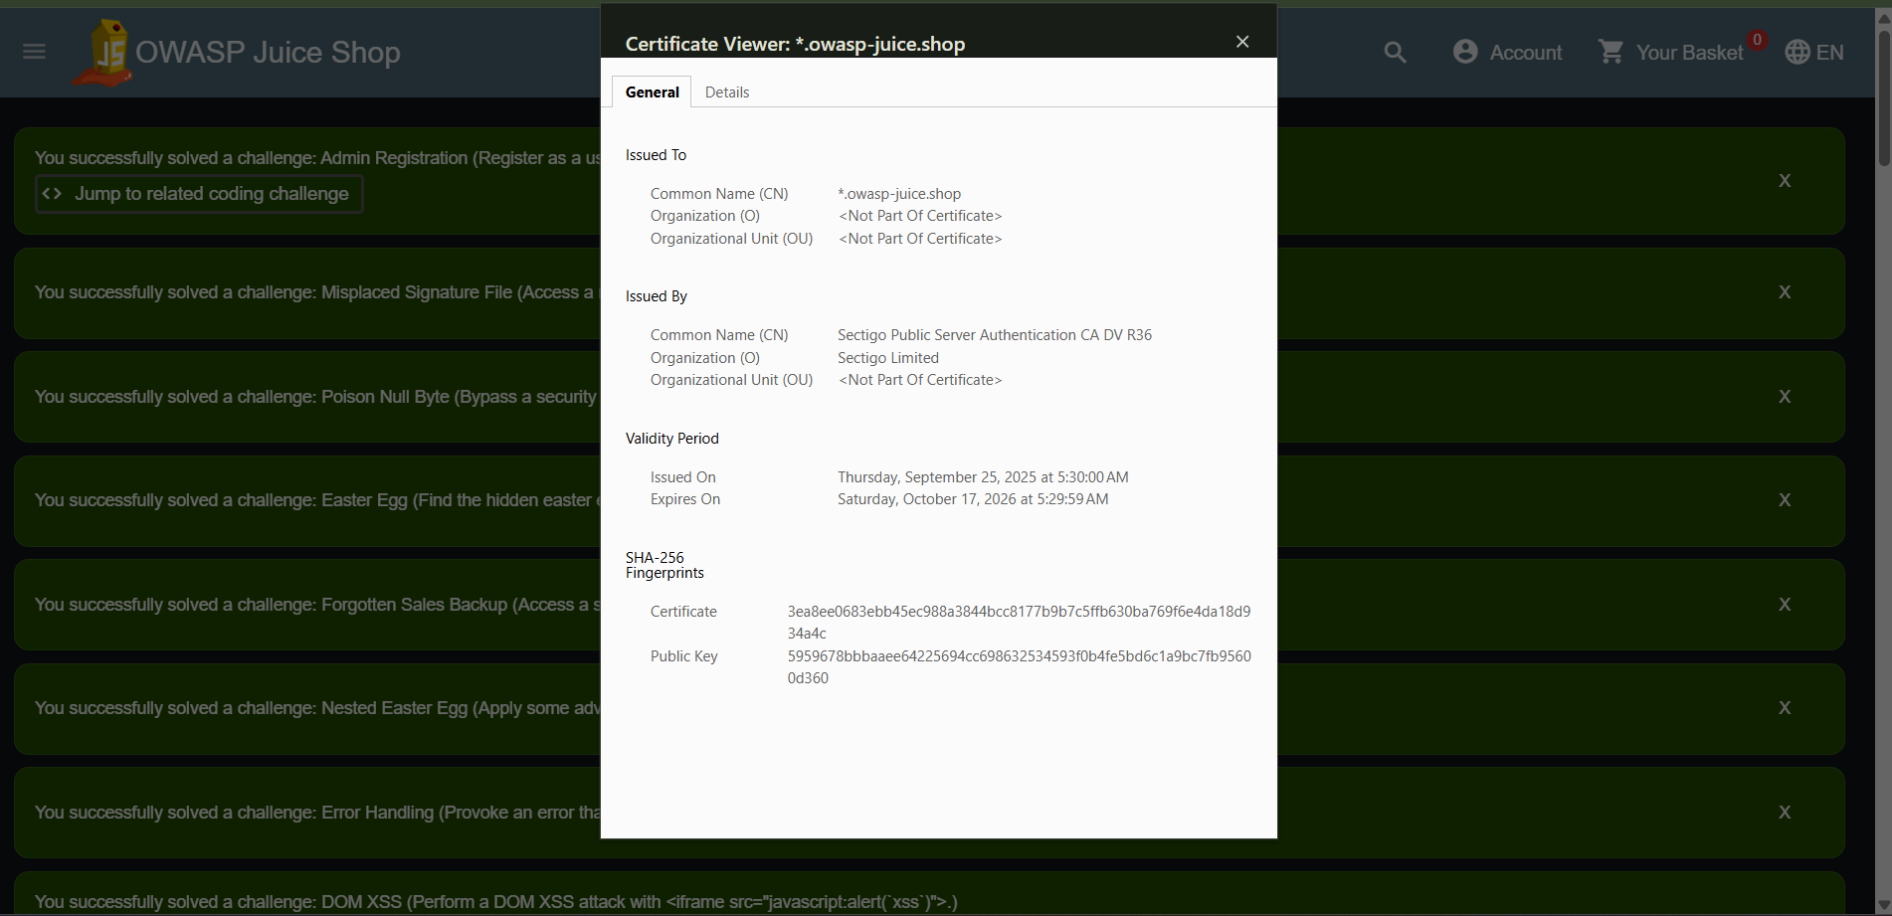

- Nmap : Nmap scan revealed port 3000/TCP open running an unencrypted HTTP service powered by Node.js Express framework. No HTTPS service was detected on port 443, indicating the complete absence of SSL/TLS encryption. The X-Powered-By: Express header was visible in responses, confirming technology disclosure. These findings map to OWASP A02 (Cryptographic Failures) and A05 (Security Misconfiguration).
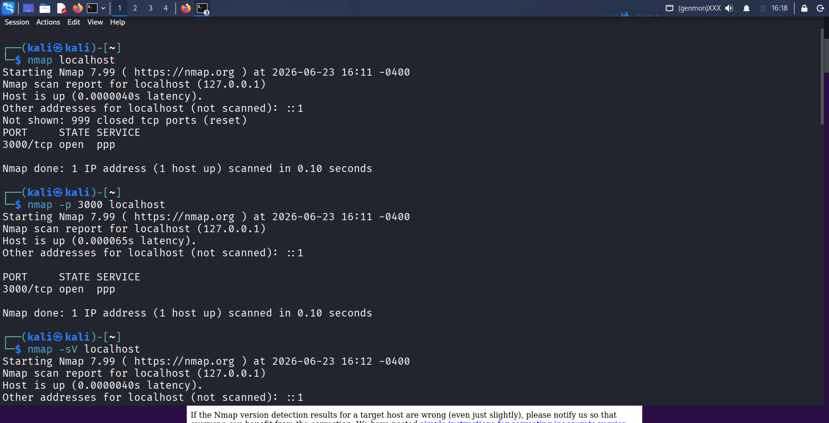
- Crt.sh : crt.sh is a free online tool and database that searches Certificate Transparency (CT) logs to find all SSL/TLS certificates issued for a domain. It helps security assessors discover subdomains, related domains, and certificate history of a target.
- It have total 13 SSL/TLS Certficates .
- Subject Public Key Info : Public key Algorithm → rsaEncryption (3072 bits)
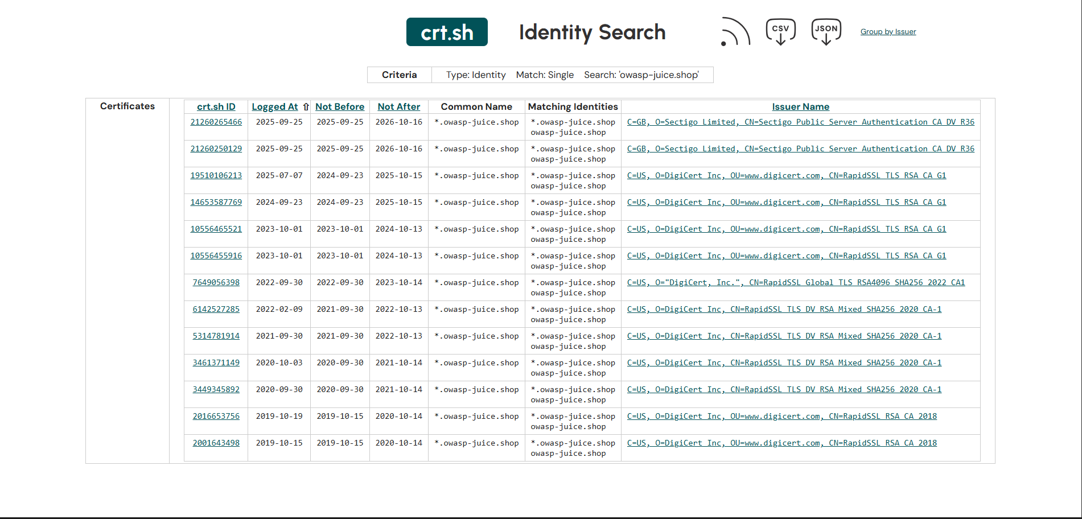

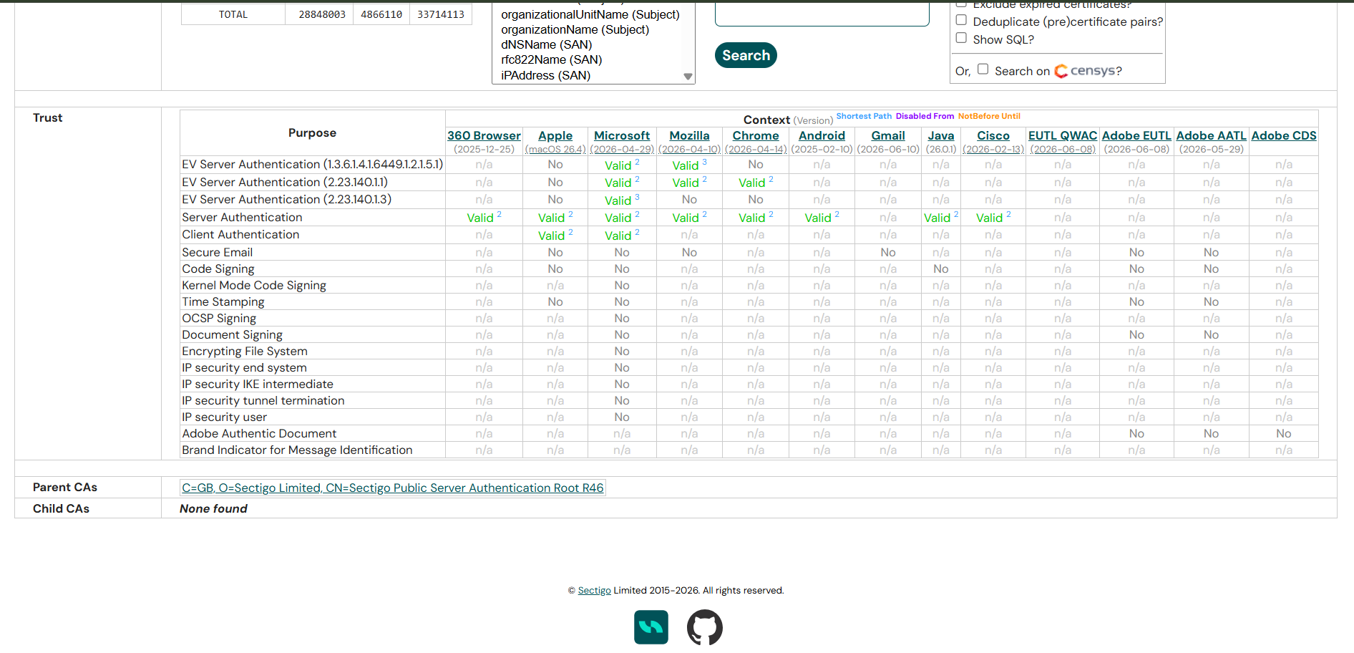

Attack Surface Assessment
The goal of Attack Surface Assessment is to identify all places were an attacker might interact with the application or its supporting infrastructure. There are some common entry points include :
WW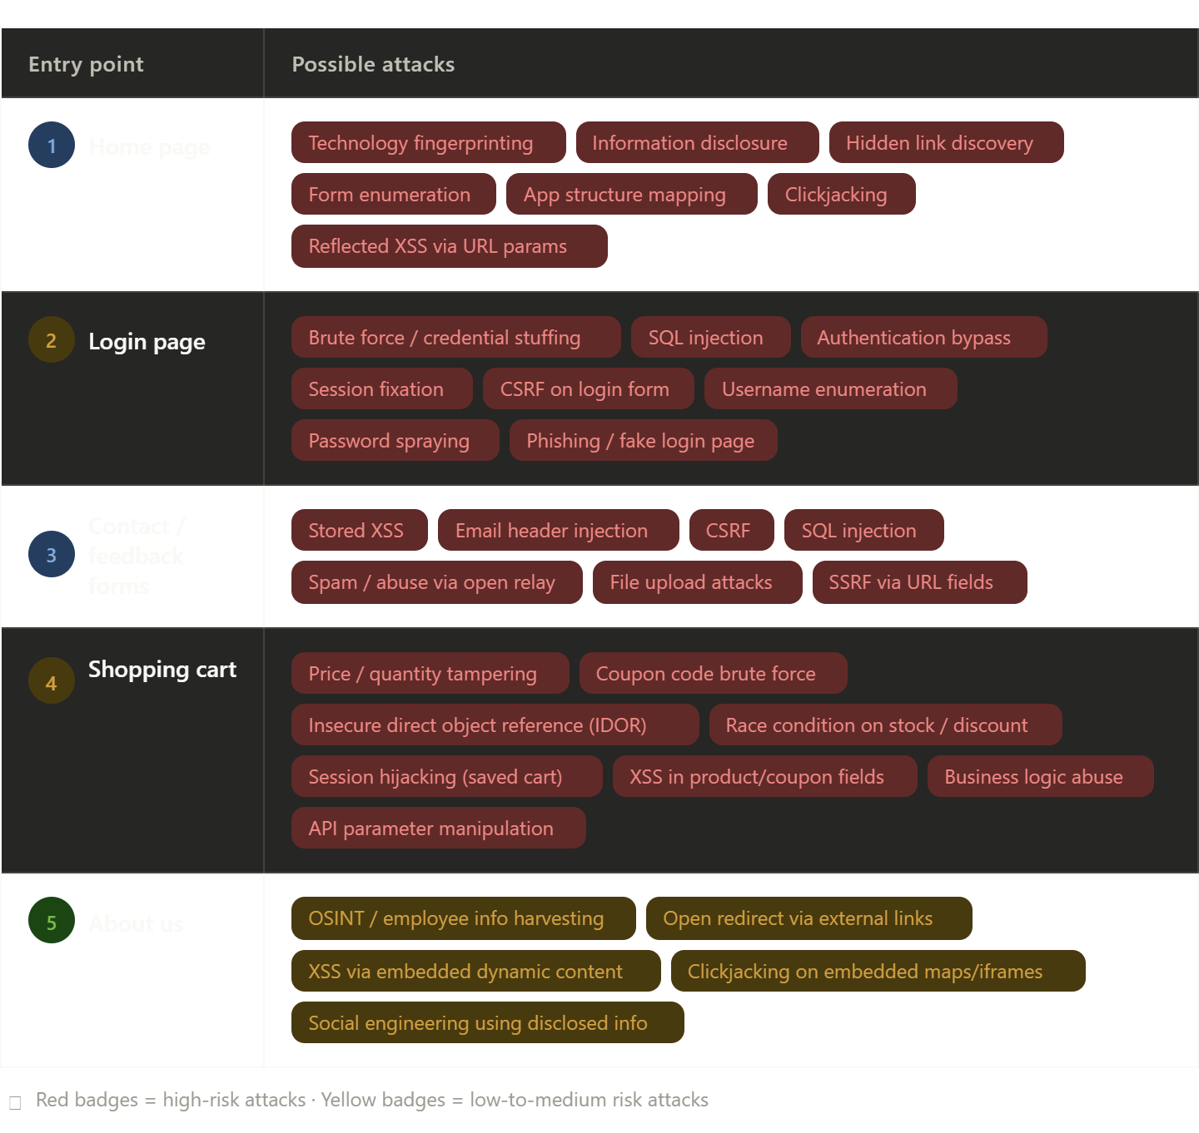
Why identifying entry points is important ?
- Risk prioritization – Knowing where users and systems interact with the application helps focus security testing on the most exposed components.
- Defence Planning : Mapping entry points enables appropriate controls such as authentication, input validation, rate limiting, and monitoring to be applied where needed.
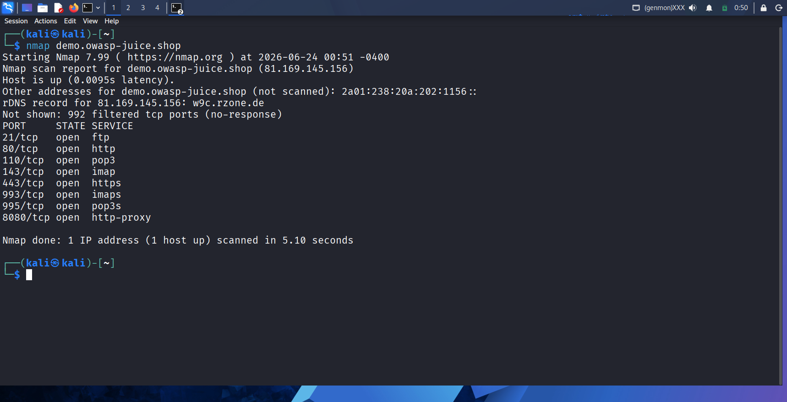
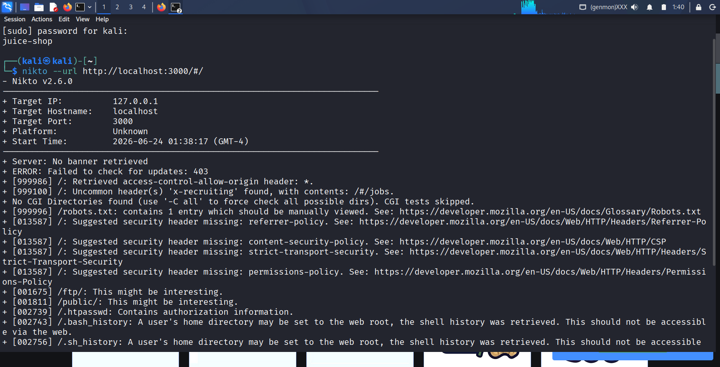

OWASP RISK MAPPING
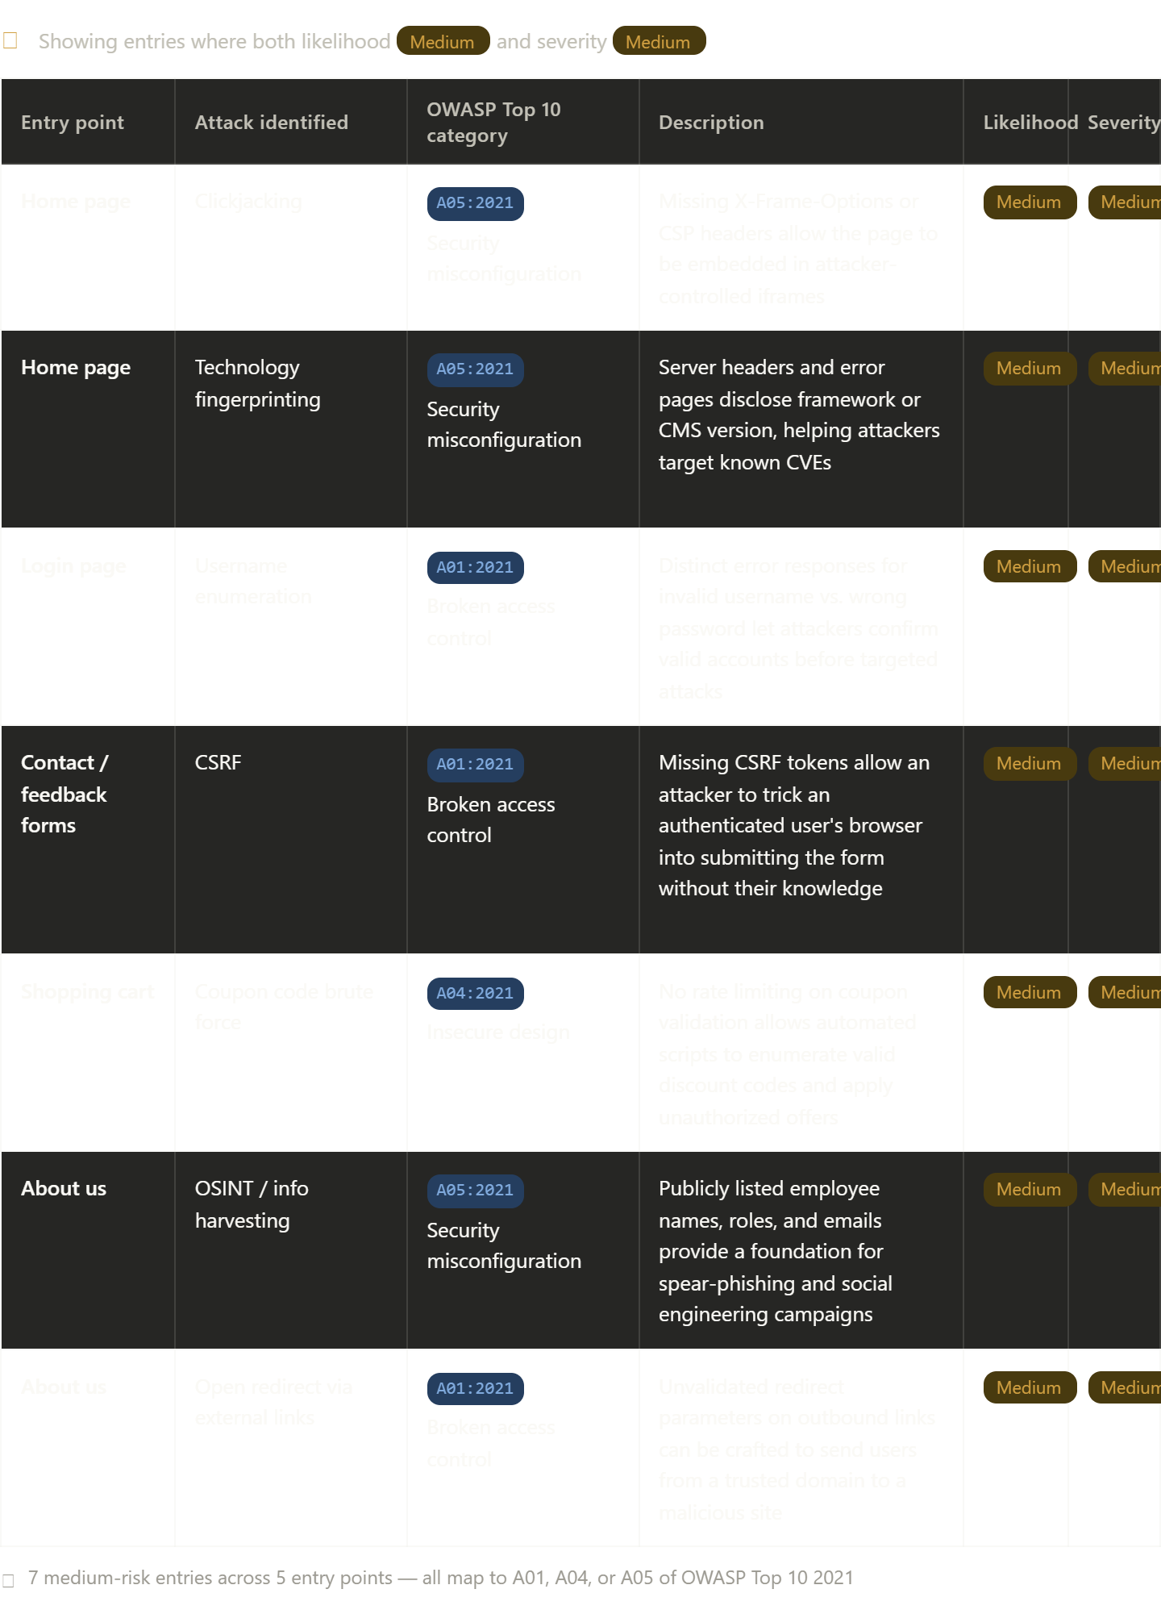
Risk Register
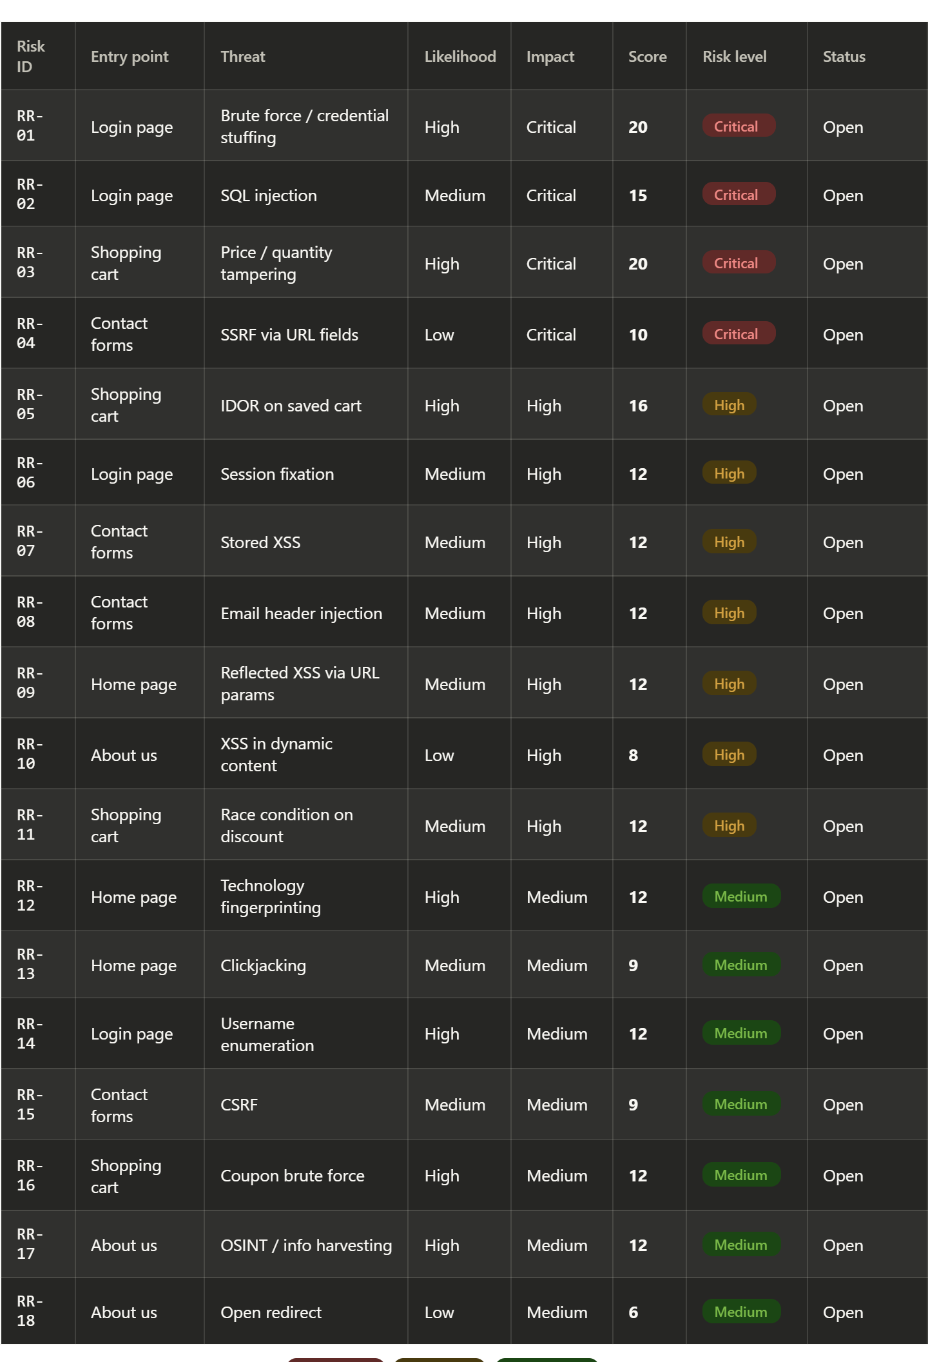
Recommendations
- Immediate Actions :
- Brute Force / Credential Stuffing : Implement MFA, account lockout, rate limiting, CAPTCHA, IP reputation filtering, password breach detection.
- SQL Injection : Use parameterized queries, prepared statements, ORM protections, input validation, WAF rules, secure code review.
- IDOR on Saved Cart : Implement object-level authorization checks on every request.
- Session Fixation : Regenerate session IDs after authentication and privilege changes.
- Reflected XSS : Context-aware output encoding and CSP.
- Technology Fingerprinting : Remove version banners, minimize information disclosure.
- OSINT / Info Harvesting : Review publicly exposed information and metadata.
- Coupon Brute Force : Rate limiting, coupon complexity, monitoring
Conclusion
This project involved conducting a security assessment and risk analysis of the intentionally vulnerable web application OWASP Juice Shop. The objective was to identify, evaluate, and prioritize security vulnerabilities based on their likelihood and potential business impact, following a structured risk management approach.

The assessment identified 18 security risks, including vulnerabilities related to authentication, authorization, input validation, session management, business logic, and client-side security controls. The findings revealed 4 Critical, 7 High, and 7 Medium-risk issues, demonstrating that web applications are susceptible to a wide range of attacks if secure development practices are not consistently applied.

The most significant risks included Brute Force/Credential Stuffing, SQL Injection, Price/Quantity Tampering, and SSRF, all of which could result in unauthorized access, data breaches, financial fraud, or compromise of backend systems. Additional findings such as IDOR, XSS, Session Fixation, CSRF, and Race Conditions highlighted the importance of implementing robust access controls, secure session handling, and comprehensive input validation throughout the application.

In conclusion, the OWASP Juice Shop project provided valuable insight into common web application vulnerabilities and their associated business risks. It reinforced the importance of integrating security into every stage of the software development lifecycle and adopting a proactive approach to vulnerability management. By addressing the identified findings and conducting regular security assessments, organizations can significantly improve their security posture, reduce the likelihood of successful attacks, and enhance the overall resilience of their web applications.

